**Spike:** Spike No.13

**Title:** Task 13 – Command Pattern

**Author:** Khang Trinh - 102118468

**Goals / Deliverables:**

The goal of this spike is to teach the developer how to implement the command system.

**Technologies, Tools, and Resources used:**

* Visual Studio 2017

**Useful Links:**

1. Explanation and example of implementation:

<https://gameprogrammingpatterns.com/command.html>

# Tasks undertaken:

Implementing the command pattern requires 3 components:

* An abstract class holding the structure of a command
* The implementations of the command (the commands themselves)
* A manager class that contains all the available commands and handles reading input and executing those commands

For this spike, we’ll create basic command handling for a text-based adventure game. It’ll have 3 commands: Go, Help, and Change. 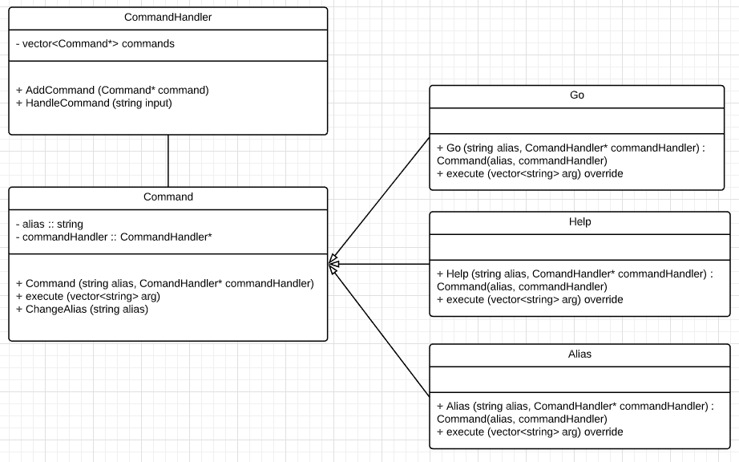

If you’ve ever used a bot in any social media before (Discord bots, Twitch bots, etc.), you’ll know that to make a bot execute a command, you need to provide it an alias (the name of the command), and any argument that it requires to execute said command.

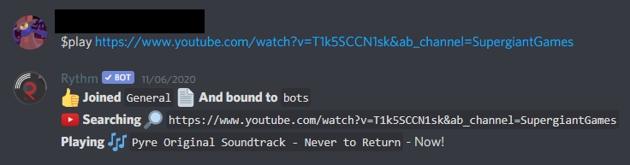

Fig . An example of a bot taking a command "play" to play a youtube link

## Step 1: Command structure

All basic commands need to have an alias to identify itself, and a method to execute a command when called. Since different commands will do different things, we’ll start by implementing a generic base class with the execution method being virtual.

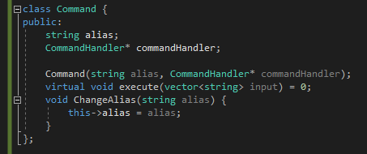

It’ll also need a reference to the CommandHandler class to add itself to the list of commands when initialized.

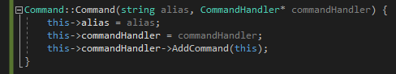

## Step 2: Command Handler

Then we need to create the Command Handler, adding a method to add commands into the list and a method to “read” and execute the input from the user. To “read” an input, we need to break the string down, splitting it by whitespace and putting them in a vector so we can iterate through later to get the arguments. For this example, we assume the first element of the input will always be the alias, so we’ll compare that to the command’s alias. If there’s a match, we’ll call execute() on that command, passing the entire vector into it.

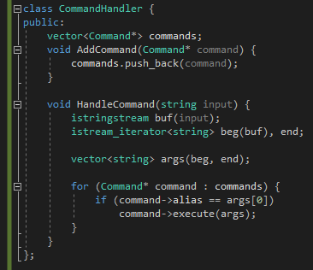

## Step 3: Implementing the *actual* commands

With the way we have the Command class setup, creating a new command is as simple as providing a constructor (inheriting it from the Command class), and an override method of the execute() function. You’ll notice that each command may use one, or more, or no arguments.

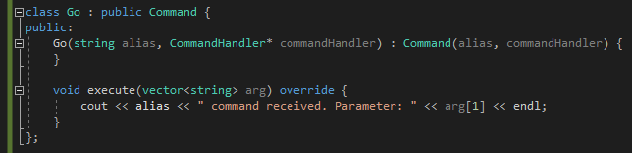

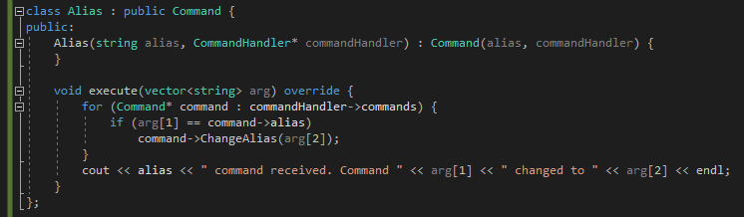

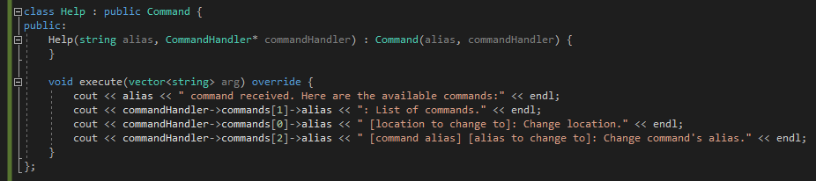

## Step 4: Getting the user input

Note that getlin() is used, rather than cin >> input. This is to make sure everything the user types is recorded.

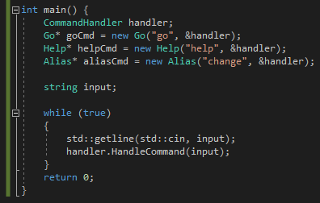

This is what the output should look like

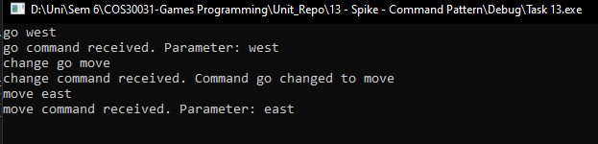

# What we found

* As demonstrated above, this pattern works best when you have inputs that may be changed in the future. This could be keyboard event or a command alias being different but still execute the same function.

# Recommendation

* Generally a command will come in the form of “[alias] [arg 1] [arg 2] [arg n]” (see example of the music bot at the beginning), so we assumed that this is what the user will enter. Make sure to always communicate the convention you want them to use.
* You may want to implement an input sanitizer to keep the user from exploiting your code (especially if you’ll be dealing with handling a database).
* On that same note, you may also want to put a rule to how many arguments a command should take, so that the program will return an error to the user, rather than executing with missing/too many arguments.